The correlation between latitude and temperature factors is 0.58. It’s a positive correlation.

Norther hemisphere has warmer temperature regions than southern, range from 12c to 41c. Southern hemisphere has cooler temperature, range from 5c to 35c.

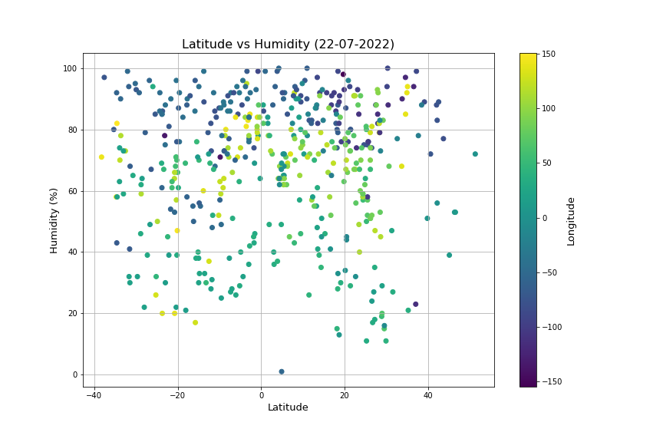

The correlation between latitude and humidity factors is 0.02 (r < 0.3). There is none or extremely weak correlation.

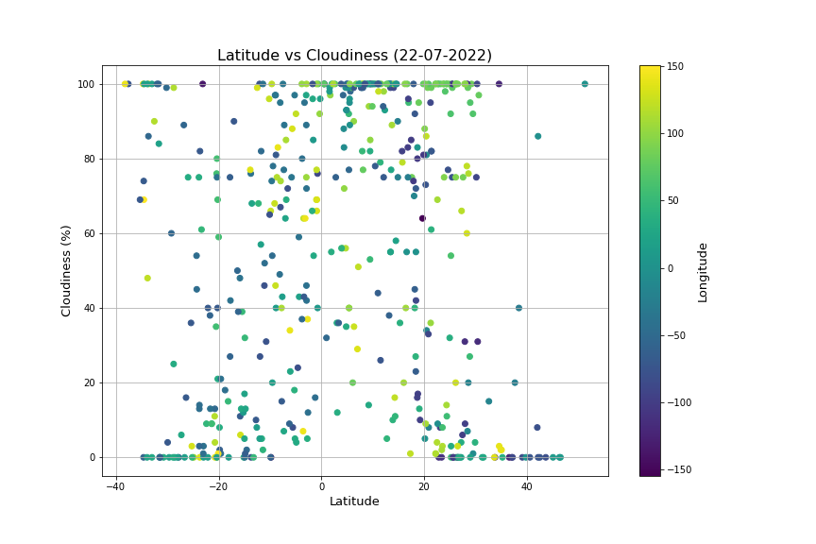

The correlation between latitude and cloudiness factors is 0.06 (r < 0.3). There is none or extremely weak correlation.

The correlation between latitude and wind speed factors is 0.11 (r < 0.3), it’s a none or extremely weak correlation.

Majority of cities have wind speed from 0 to 6mps or 13.4mph, from calm to moderate breeze. Some have fresh breeze, few have strong breeze.

